***JAYPEE INSTITUTE OF INFORMATION***

***TECHNOLOGY, NOIDA , SECTOR-62***



***ENGLISH* *: 15B11HS112***

***INTERNAL ASSESSMENT***

***Project : creative writting***

***SUBMITTED TO:***

***Mrs. DEBJANI SARKAR ma’am***

***BY :***

***TEAM MEMBERS (B10 BATCH):***

* ***HIMANSHU DIXIT (B64178)***
* ***AASHUTOSH PRADHAN (B61308)***
* ***ARYAMAN VISHNOI (B63816)***
* ***ARYAN RAZDAN (BJ61567)***

***(BTECH – CSE 1st year ODD SEMESTER 2021)***

***CHOICE OF WORD : BELIEVE***

We have chosen this word because whenever we feel demotivated or depressed , and feel bad this word give us potential to move forward with positive attitude and help us to do that work which we feel difficult. So, this is the greatest reason why we chose this word.

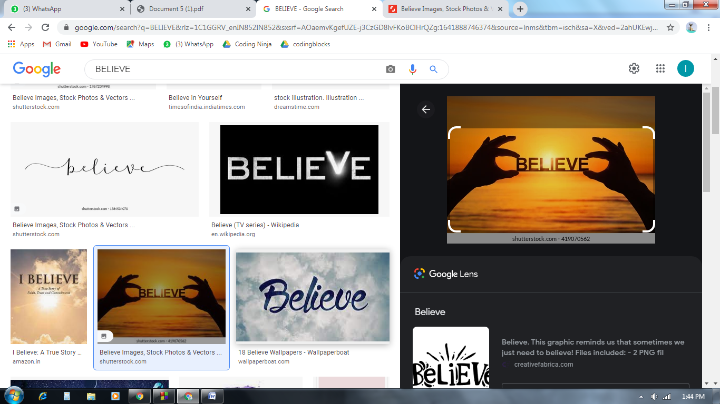

***TITLE OF POEM : BELIEVE***

Believe Something that gives our hope alive,

something that stops us thinking twice,

something that justify our choice,

something that describes our life.

There are people to make you fall,

believe in yourself 'cause these people are just like walls;

never think you were alone in this world,

there's one who is always concerned;

one can stop or nab your passion,

until you are on your path with dedication;

a person to trust have faith in us and believe in yourself,

and not just words to condemn ourselves;

it's the virtue to our path leading us the way,

the value of which we can never pay.

Tracing our parts till the day we were born,

believe was all we did from ducks till dawn;

it is so easy to break if not certain,

believe those who were there for you when things were uncertain;

believe in yourself and in your dream,

though impossible things may seem;

believe in yourself and in your plan,

don't say I cannot but say I can;

if you believe in yourself ,

you will reach high,

you will have that hope to reach the sky.

Believe in yourself and of what you are capable,

it will keep you hopes alive and will make your unstoppable;

believe in your own thoughts and never doubt your instinct,

because all the great minds we praise worthy ones who thought distinct.

***LITERARY DEVICES***

1. Rhyme - It is used in entire poem.

Eg.- twice-choice, fall-walls, world-concerned, passion-dedication, yourself-ourselves, way-pay, born-dawn, certain-uncertain, dream-seem,plan-can, high-sky, capableunstoppable, instinct-distinct.

1. Simile - Eg.-Believe in yourself, ‘cause these people are just like walls.
2. Anaphora - Eg.-Believe
3. Oxymoron - Eg.-dusk to dawn
4. Alliteration - Eg.-dusk and dawn

***Important words***

1. **Believe –** accept that (something) is true, especially without proof.
2. **Condemn –** express complete disapproval of; censure.
3. **Nab –** catch (someone) doing something wrong.
4. **Virtue –** behaviour showing high moral standards.
5. **Instinct –** the natural force that causes a person or animal to behave in a

particular way without thinking or learning about it

***Contribution of each member***

1. ***ARYAN RAZDAN (BJ61567)***

1st Stanza , some ideas for the poem and pointing out the important words.

1. ***HIMANSHU DIXIT (B64178)***

2nd Stanza ,Cover page designing ,typing and formatting the assignment and some ideas for the poem.

1. ***AASHUTOSH PRADHAN (B61308)***

3rd Stanza , some ideas for the poem and literary devices.

1. ***ARYAMAN VISHNOI (B63816)***

4th Stanza, idea and points regarding the theme of the poem and pointing out the literary devices.

***Conclusion***

First of all we gratitude our thanks to our English teacher who provided us chance to explore different things and work on this project. Through this project we came know about team work ,explored different words and extended our imagination. We hope that whatever we have gained through this project will be useful in future.